

POLY MAILER BAGS

PRODUCT CODE | WIDTH (INCH) | Length (INCH) | Lip (INCH) | Gauge (MIL) | BAGS/  CASE | FILM  COLOR | CASES/  PALLET | CASES/LAYER | CASE  CUBE | UPC#  7-62935-
MB1215NP | 12 | 15 | 1.5 | 2.5 | 500 | White/Gray | 64 | 8 | 0.7408 | 082963
MB1419NP | 14 | 19 | 1.5 | 2.5 | 500 | White/Gray | 64 | 8 | 0.7408 | 080297
MB1924NP | 19 | 24 | 1.5 | 2.5 | 250 | White/Gray | 32 | 4 | 0.6771 | 080303
Custom made | 9”~29” | 9”~32” | 2”~3” | 2.0~6.0 | 250/500 | Custom | - | - | - | -
** Minimum 150,000 bags per custom order
** 4 weeks lead time. Larger orders subject to 12-14 weeks lead time
** For additional sizes please contact your Sales Representative
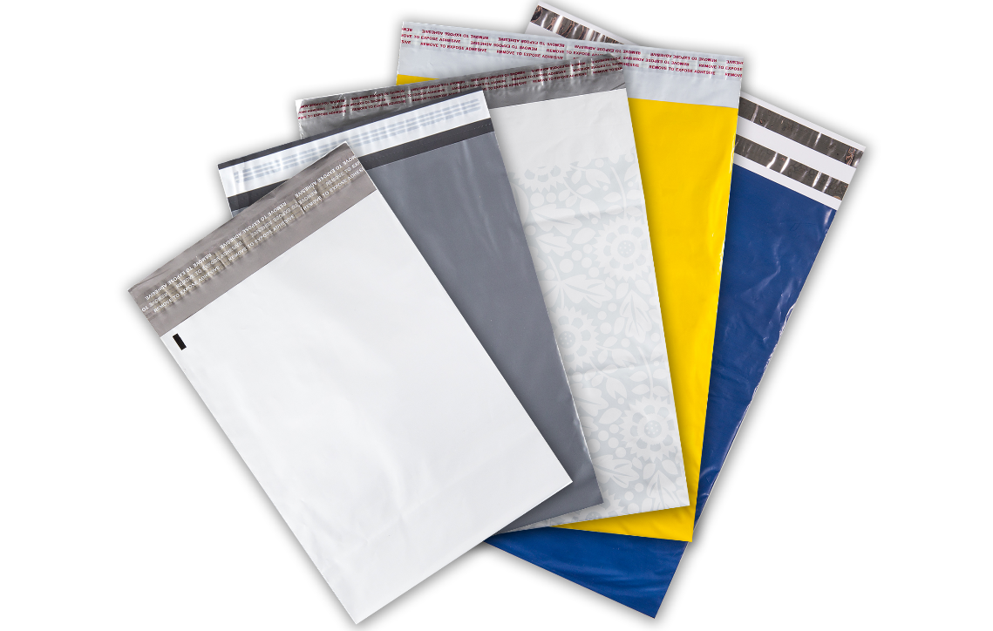
Features & Benefits
- Single self-seal adhesive white liner for easy closure
- Light weight to save on postage
- 100% recyclable
- Water, tear and puncture resistant
- Tamper proof
- Non-printed
- Domestic/Import manufacturing

Applications
- Retail Stores
- Pharmacy Mail order service
- Department Stores
- E-commerce

Custom Options
- Custom sizes available
- Popular Sizes: 9”x12”+1.5” Lip; 12”x15”+1.5”; 14”x19”+1.5”; 19”x24”+1.5”; and 24”x30”+1.5”
- Single or dual self-seal adhesive liners on clear, white or silver
- Perforated single tear-strip for easy opening and double tear strip for returns
- Up to 12 color print for regular or process print
- Recycled material content available upon request
- Mailer on wicket available
- Bubble lining available for product safety

